Code for implementing Reader-Writer problem (System programming)
Program to implement Reader-writer problem using mutex/ semaphore.
Download : Source Code
Description: According to this problem, multiple processes read the database at the same time, but if one process is updating (writing) the database, no other processes may have access to the database, not even readers.
Code :
#include<stdio.h>
#include<sys/types.h>
#include<stdlib.h>
#include<pthread.h>
#include<semaphore.h>
#define N 5
int b;
int readcount;
sem_t mutex,wrt;
void* w()
{
int i=1;
for(i=0;i<N;i++)
{
sem_wait(&wrt); //wait
b=i;
i++;
//Writing is performed
printf(“\nW :written =%d”,b);
sem_post(&wrt); //signal
printf(“\nW going to sleep..”);
sleep(2);
}
printf(“Writer is living”);
}
void * r(void * a)
{
int *rr =(int *) a ;
int i;
for(i=0;i<N;i++)
{
sem_wait(&mutex);
readcount++;
if(readcount==1)
sem_wait(&wrt);
sem_post(&mutex);
//Readind is performed
printf(“\nR :read=%d Reader no.=%d “,b,*rr);
printf(“\nReader%d:going to sleep…”,*rr);
sleep(2);
sem_wait(&mutex);
readcount--;
if(readcount==0) //to check last reader
sem_post(&wrt);
sem_post(&mutex);
}
printf(“Reader no.=%d living”,*rr);
}

void main()
{
pthread_t w1,w2,r1,r2;
int rr1=1,rr2=2;
b=0;
readcount=0;
printf(“\n value of shared variable is %d”,b);
sem_init(&(wrt),0,1);
sem_init(&(mutex),0,1);
//Creating Threads
pthread_create(&w1,NULL,w,NULL);
pthread_create(&r1,NULL,r,(void * )&rr1);
pthread_create(&r2,NULL,r,(void * )&rr2);
pthread_join(w1,NULL);
pthread_join(r1,NULL);
pthread_join(r2,NULL);
}
Output :-
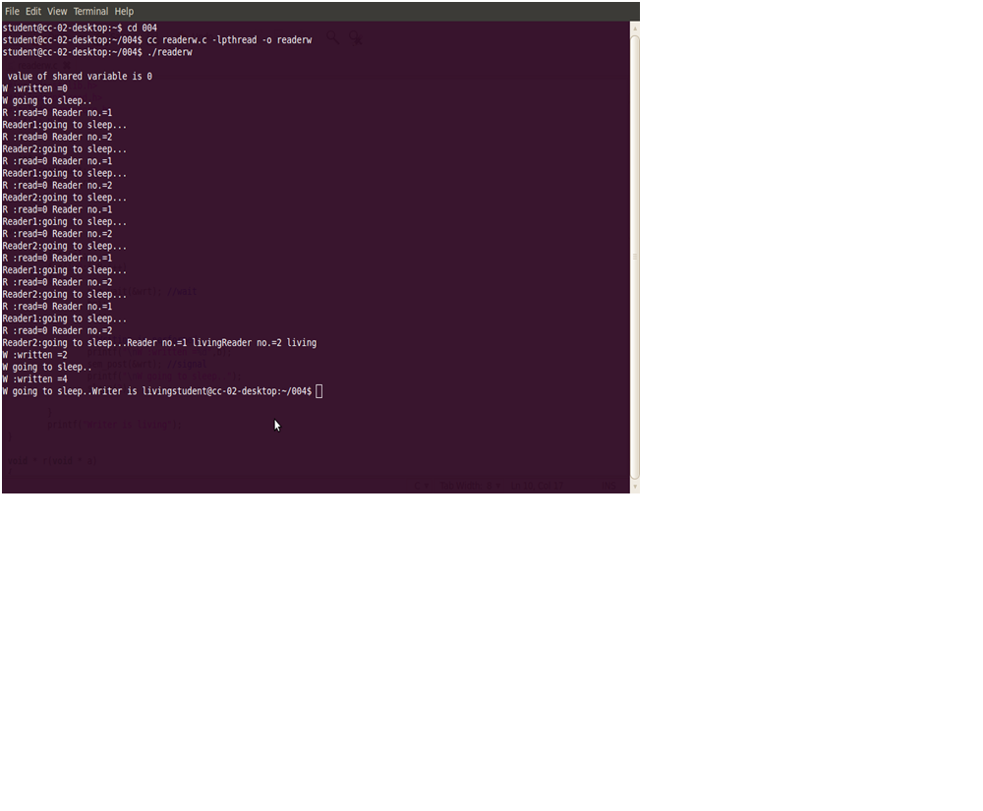

Posix semaphores
All POSIX semaphore functions and types are prototyped or defined in semaphore.h. To define a semaphore object, use
sem_t sem_name;

To initialize a semaphore, use sem_init:
int sem_init(sem_t *sem, int pshared, unsigned int value);
- sem points to a semaphore object to initialize
- pshared is a flag indicating whether or not the semaphore should be shared with fork()ed processes. LinuxThreads does not currently support shared semaphores
- value is an initial value to set the semaphore to
Example of use:
sem_init(&sem_name, 0, 10);

To wait on a semaphore, use sem_wait:
int sem_wait(sem_t *sem);
Example of use:
sem_wait(&sem_name);
- If the value of the semaphore is negative, the calling process blocks; one of the blocked processes wakes up when another process calls sem_post.

To increment the value of a semaphore, use sem_post:
int sem_post(sem_t *sem);
Example of use:
sem_post(&sem_name);
- It increments the value of the semaphore and wakes up a blocked process waiting on the semaphore, if any.

To find out the value of a semaphore, use
int sem_getvalue(sem_t *sem, int *valp);
- gets the current value of sem and places it in the location pointed to by valp
Example of use:
int value;
sem_getvalue(&sem_name, &value);
printf("The value of the semaphors is %d\n", value);

To destroy a semaphore, use
int sem_destroy(sem_t *sem);
- destroys the semaphore; no threads should be waiting on the semaphore if its destruction is to succeed.
Example of use:
sem_destroy(&sem_name);

Using semaphores - a short example
Consider the problem we had before and now let us use semaphores:

Declare the semaphore global (outside of any funcion):

sem_t mutex;

Initialize the semaphore in the main function:

sem_init(&mutex, 0, 1);

C PROGRAM FOR READER WRITER PROBLEM
By Umesh Toke | April 18, 2014
2 Comments
NOTE: To Execute the following program you need to type the given below command in to the terminal gcc filename.c -lpthread

REASON: “The header pthread.h is used so that the compiler understands the data types & symbol names, which are used in the below given C program but are defined/declared in the pthread library header file. pthread libray is linked using -lpthread ,so that the linker can actually find those symbols in the pthread library during the linking stage.”
SOURCE CODE

#include<stdio.h>
#include<pthread.h>
#include<semaphore.h>
sem_t readCountAccess;
sem_t databaseAccess;
int readCount=0;
void *Reader(void *arg);
void *Writer(void *arg);
int main()
{
int i=0,NumberofReaderThread=0,NumberofWriterThread;
sem_init(&readCountAccess,0,1);
sem_init(&databaseAccess,0,1);
pthread_t Readers_thr[100],Writer_thr[100];
printf(“\nEnter number of Readers thread(MAX 10)”);
scanf(“%d”,&NumberofReaderThread);
printf(“\nEnter number of Writers thread(MAX 10)”);
scanf(“%d”,&NumberofWriterThread);
for(i=0;i<numberofreaderthread;i++)
{
pthread_create(&Readers_thr[i],NULL,Reader,(void *)i);
}
for(i=0;i<numberofwriterthread;i++)
{
pthread_create(&Writer_thr[i],NULL,Writer,(void *)i);
}
for(i=0;i<NumberofWriterThread;i++)
{
pthread_join(Writer_thr[i],NULL);
}
for(i=0;i<NumberofReaderThread;i++)
{
pthread_join(Readers_thr[i],NULL);
}
sem_destroy(&databaseAccess);
sem_destroy(&readCountAccess);
return 0;
}
void * Writer(void *arg)
{
sleep(1);
int temp=(int)arg;
printf(“\nWriter %d is trying to enter into database for modifying the data”,temp);
sem_wait(&databaseAccess);
printf(“\nWriter %d is writting into the database”,temp);
printf(“\nWriter %d is leaving the database”);
sem_post(&databaseAccess);
}
void *Reader(void *arg)
{
sleep(1);
int temp=(int)arg;
printf(“\nReader %d is trying to enter into the Database for reading the data”,temp);
sem_wait(&readCountAccess);
readCount++;
if(readCount==1)
{
sem_wait(&databaseAccess);
printf(“\nReader %d is reading the database”,temp);
}
sem_post(&readCountAccess);
sem_wait(&readCountAccess);
readCount–;
if(readCount==0)
{
printf(“\nReader %d is leaving the database”,temp);
sem_post(&databaseAccess);
}
sem_post(&readCountAccess);
}

OUTPUT

Enter number of Readers thread(MAX 10)2
Enter number of Writers thread(MAX 10)1
Reader 0 is trying to enter into the Database for reading the data
Reader 0 is reading the database
Reader 0 is leaving the database
Reader 1 is trying to enter into the Database for reading the data
Reader 1 is reading the database
Reader 1 is leaving the database
Writer 0 is trying to enter into database for modifying the data
Writer 0 is writing into the database
Writer 0 is leaving the database

Readers Writers Problem - Semaphore - Systems Lab - C Program
//Readers Writers Problem -OS Lab
Program:
#include<stdio.h>
#include<pthread.h>
#include<semaphore.h>
sem_t mutex,writeblock;
int data = 0,rcount = 0;
void *reader(void *arg)
{
int f;
f = ((int)arg);
sem_wait(&mutex);
rcount = rcount + 1;
if(rcount==1)
sem_wait(&writeblock);
sem_post(&mutex);
printf("Data read by the reader%d is %d\n",f,data);
sleep(1);
sem_wait(&mutex);
rcount = rcount - 1;
if(rcount==0)
sem_post(&writeblock);
sem_post(&mutex);
}
void *writer(void *arg)
{
int f;
f = ((int) arg);
sem_wait(&writeblock);
data++;
printf("Data writen by the writer%d is %d\n",f,data);
sleep(1);
sem_post(&writeblock);
}
main()
{
int i,b;
pthread_t rtid[5],wtid[5];
sem_init(&mutex,0,1);
sem_init(&writeblock,0,1);
for(i=0;i<=2;i++)
{
pthread_create(&wtid[i],NULL,writer,(void *)i);
pthread_create(&rtid[i],NULL,reader,(void *)i);
}
for(i=0;i<=2;i++)
{
pthread_join(wtid[i],NULL);
pthread_join(rtid[i],NULL);
}
}

reader-writer problem using Semaphore. (writer have priority)
Program Statement:- Write a program to implement reader-writer problem using
Semaphore.
//writer have priority
#include<semaphore.h>
#include<stdio.h>
#include<pthread.h>
void *reader(void *);
void *writer(void *);
int readcount=0,writecount=0,sh_var=5,bsize[5];
sem_t x,y,z,rsem,wsem;
pthread_t r[3],w[2];
void *reader(void *i)
{
printf("\n-------------------------");
printf("\n\n reader-%d is reading",i);
sem_wait(&z);
sem_wait(&rsem);
sem_wait(&x);
readcount++;
if(readcount==1)
sem_wait(&wsem);
sem_post(&x);
sem_post(&rsem);
sem_post(&z);
printf("\nupdated value : %d",sh_var);
sem_wait(&x);
readcount--;
if(readcount==0)
sem_post(&wsem);
sem_post(&x);
}
void *writer(void *i)
{
printf("\n\n writer-%d is writing",i);
sem_wait(&y);
writecount++;
if(writecount==1)
sem_wait(&rsem);
sem_post(&y);
sem_wait(&wsem);
sh_var=sh_var+5;
sem_post(&wsem);
sem_wait(&y);
writecount--;
if(writecount==0)
sem_post(&rsem);
sem_post(&y);
}
int main()
{
sem_init(&x,0,1);
sem_init(&wsem,0,1);
sem_init(&y,0,1);
sem_init(&z,0,1);
sem_init(&rsem,0,1);
pthread_create(&r[0],NULL,(void *)reader,(void *)0);
pthread_create(&w[0],NULL,(void *)writer,(void *)0);
pthread_create(&r[1],NULL,(void *)reader,(void *)1);
pthread_create(&r[2],NULL,(void *)reader,(void *)2);
pthread_create(&r[3],NULL,(void *)reader,(void *)3);
pthread_create(&w[1],NULL,(void *)writer,(void *)3);
pthread_create(&r[4],NULL,(void *)reader,(void *)4);
pthread_join(r[0],NULL);
pthread_join(w[0],NULL);
pthread_join(r[1],NULL);
pthread_join(r[2],NULL);
pthread_join(r[3],NULL);
pthread_join(w[1],NULL);
pthread_join(r[4],NULL);
return(0);
}
/*
Output:-
student@mmcoe-desktop:~$ gcc rw1.c -lpthread
student@mmcoe-desktop:~$ ./a.out
-------------------------
reader-0 is reading
updated value : 5
writer-0 is writing
-------------------------
reader-1 is reading
updated value : 10
-------------------------
reader-2 is reading
updated value : 10
-------------------------
reader-3 is reading
updated value : 10
writer-3 is writing
-------------------------
reader-4 is reading
*/

